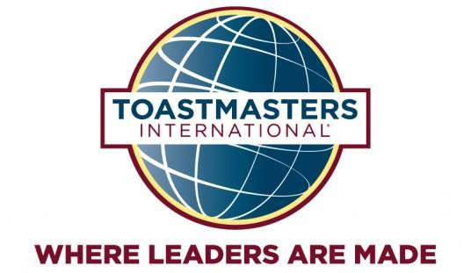

District 36 Toastmasters
Division b – “Raise the Bar”
2017 Humorous Speech & Table Topics Contests

Watch as some of Division B’s best speakers compete for the title of funniest and best impromptu speakers. Who will be this year’s champions? Join us to find out!
Friday, October 20 2016
Registration: 6:00pm
Briefing: 6:00pm (Contestants and Judges)
Contest: 6:30pm
Admission: $10.00 (free for contestants)
Location: George Washington University,
Media and Public Affairs Building
805 21st Street, NW
Room 309
Washington, DC 20052
How do I get there: https://goo.gl/maps/MUTER21xGDC2 Refreshments Provided
Raffle

To help with planning & accommodations, RSVP on Eventbrite by October 18
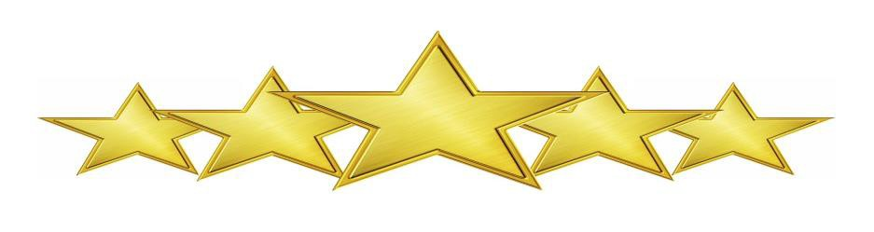
Want to volunteer? Contact Mike O’Rourke (orourke.mike.j@gmail.com) or Kevin Schell (schellkf@gmail.com).

